Understand Search Algorithms:

- Linear Search:
  - Scans each element one by one.
  - Best when the list is unsorted or small.
  - Time Complexity:
    - Best: O(1)
    - Average: O(n), Worst: O(n)

- Binary Search:
  - Works only on sorted lists.
  - Repeatedly divides the list and compares.
  - Best for large, sorted datasets.
  - Time Complexity:
    - Best: O(1)
    - Average/Worst: O(log n)

Analysis:
Algorithm | Time Complexity | Suitable When...
Linear Search | O(n) | List is unsorted or very small
Binary Search | O(log n) | List is large and sorted

Use Linear Search when:
- You don't have time to sort.
- Data is small and updated frequently.
Use Binary Search when:
- You can keep the list sorted.
- Performance is important for large data.

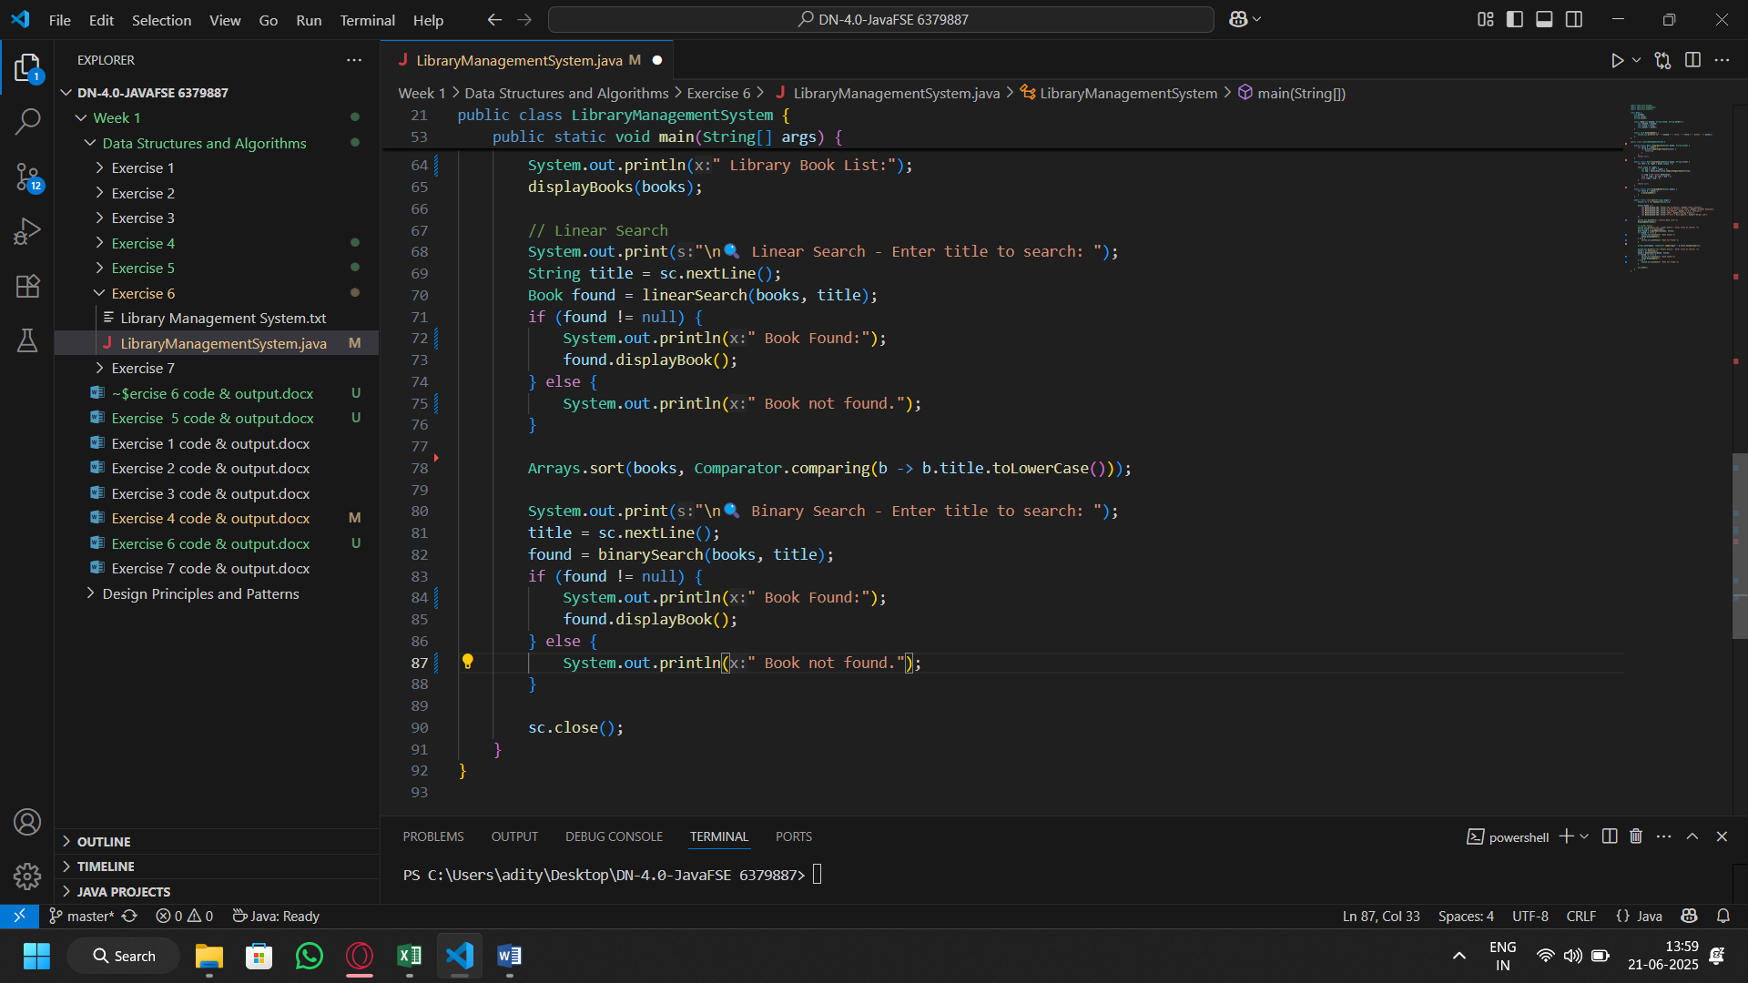
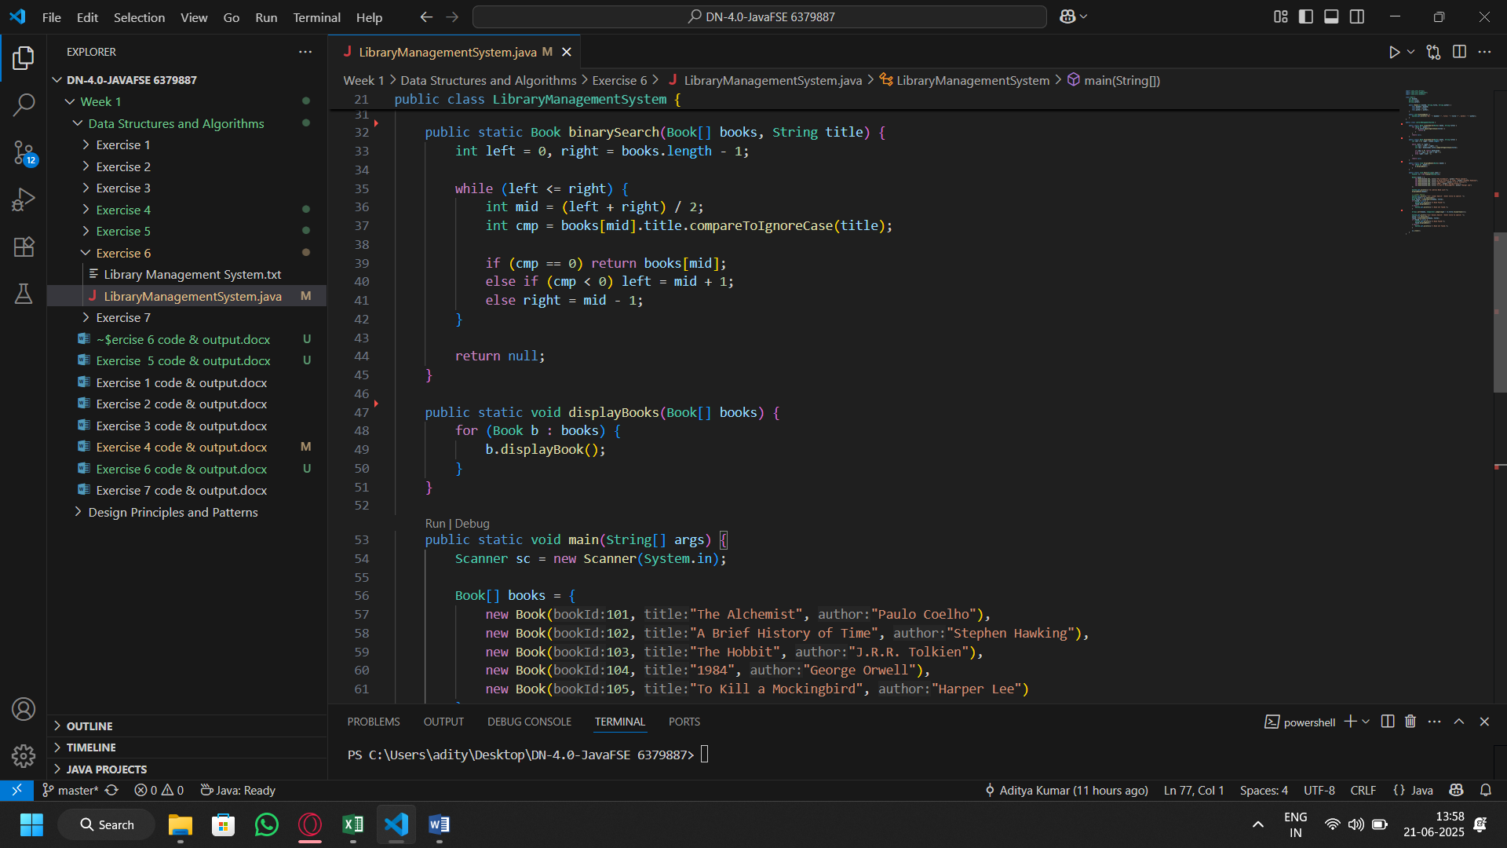
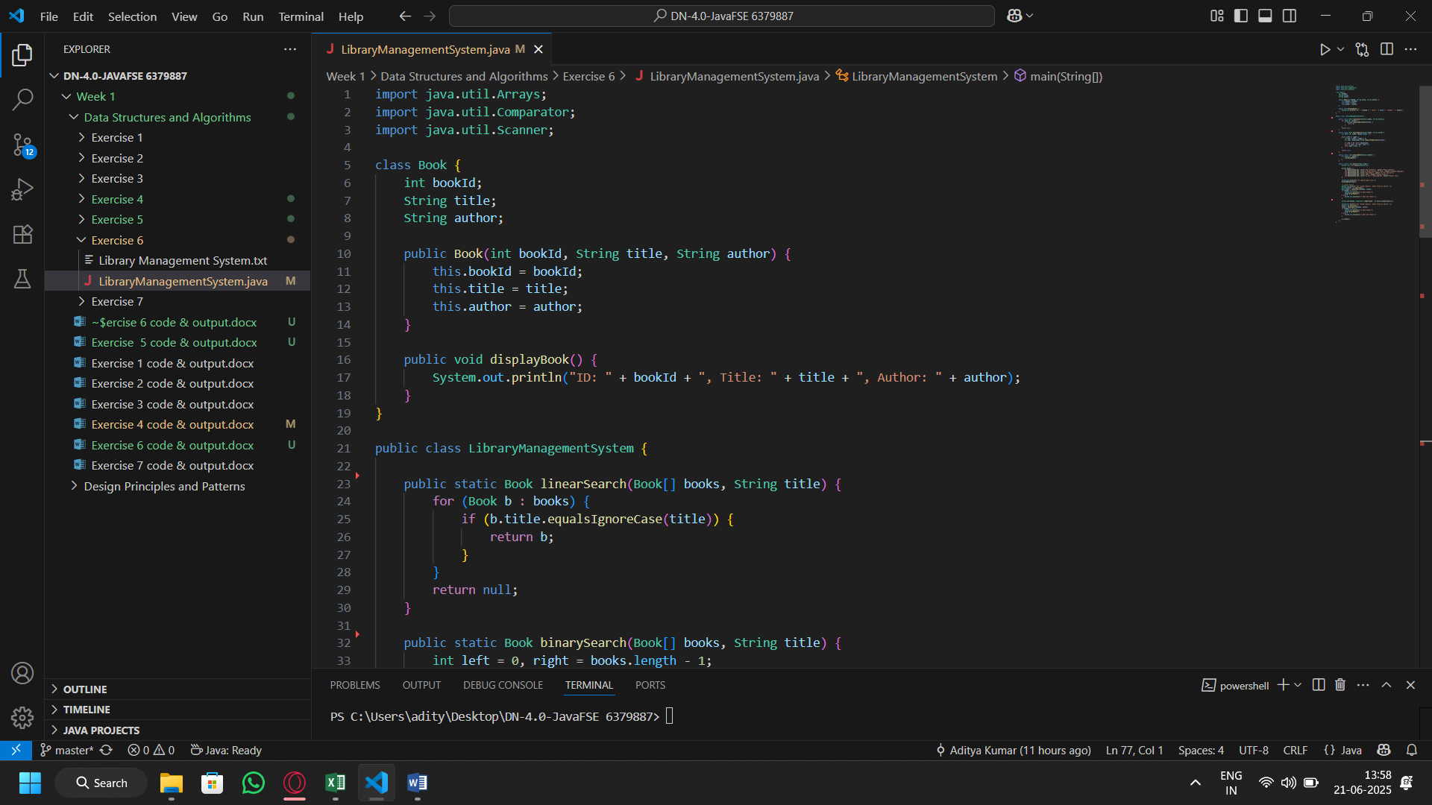
Code:

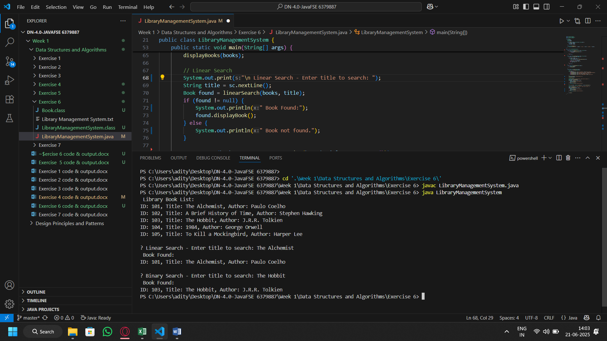
Output:

